PHP Project



Git hub: <https://github.com/akshu20791/php-project>

Prerquisite:

You need to have your own github account

Process:

1. Login to your github account

Open the link : <https://github.com/akshu20791/php-project>

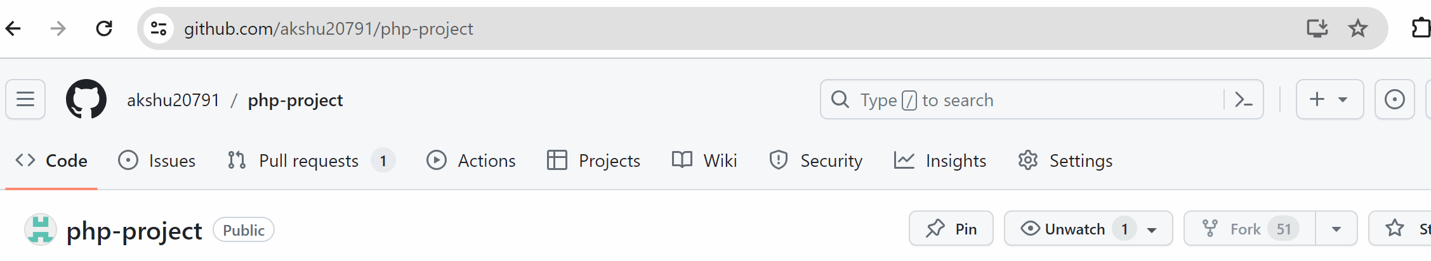



(in my case this button is not visible because I cannot fork to my own repo)

After you fork it ..lets suppose if your github username is sumanthlearner

Then your github link will become like <https://github.com/sumanthlearner/php-project>

(which means the project would be copied from akshu20791 github to your github accpunt)

….> Click on Jenkinsfile

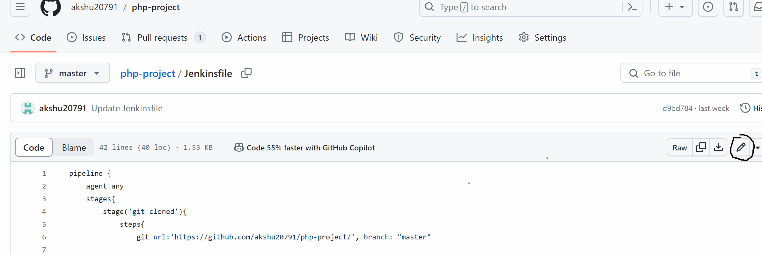

First of all replace the github url in Jenkins file with your github url

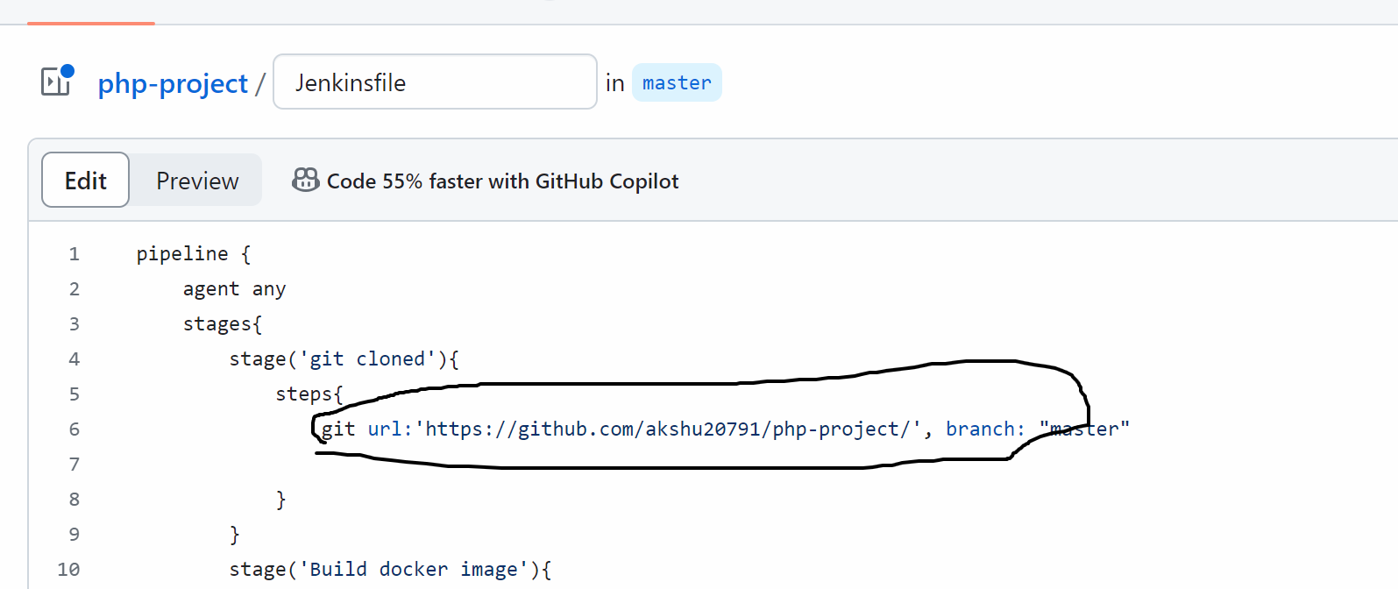



Now in your browser if you don’t have dockerhub id create dockerhuub id from <https://hub.docker.com/>

(ensure that you don’t login directly via gmail or github …fill the form to create dockerhub account)

In jenkinsfile, replace akshu20791 with your dockerhub username

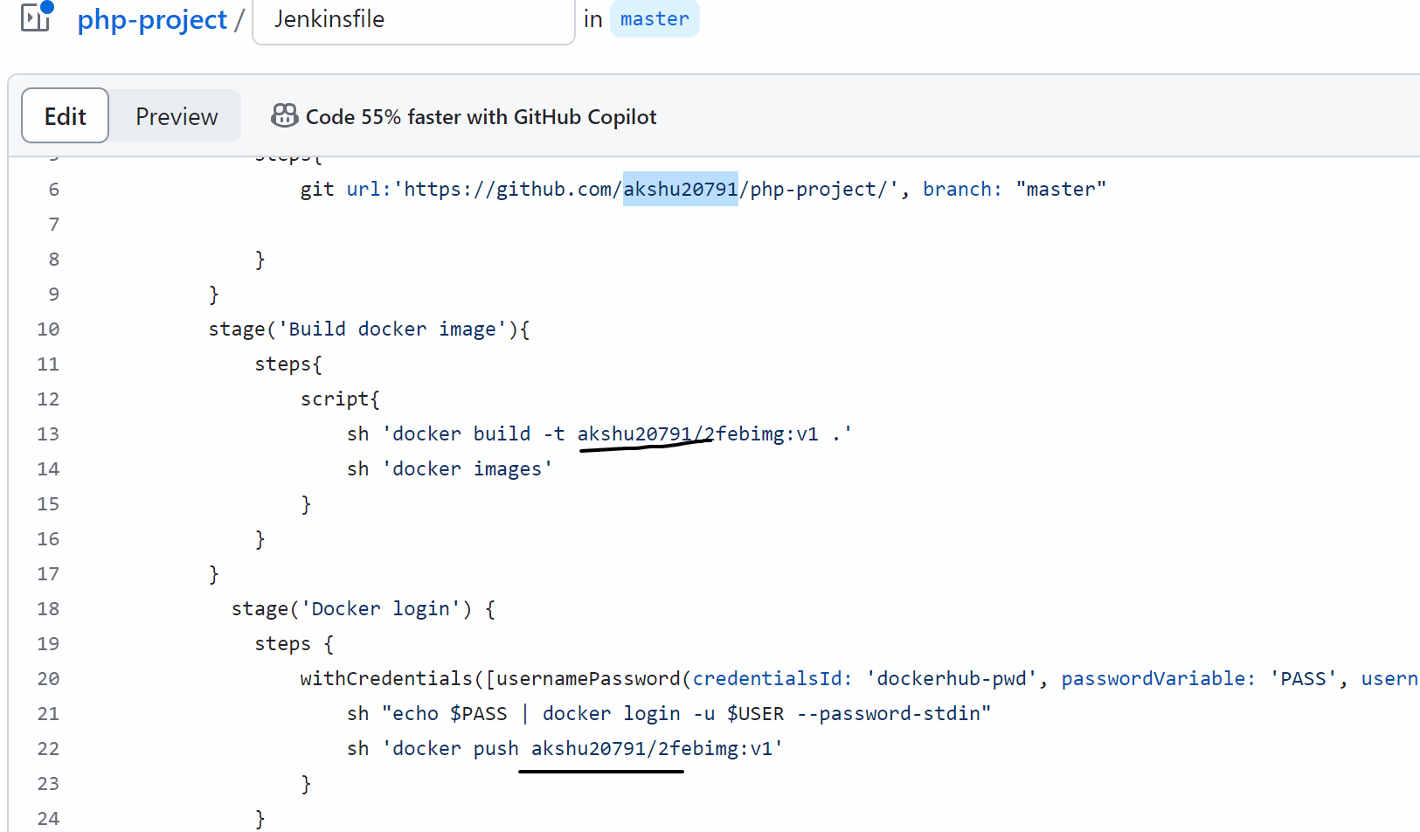

Open aws account -> ec2 -> create 2 ubuntu machine with all traffic enabled

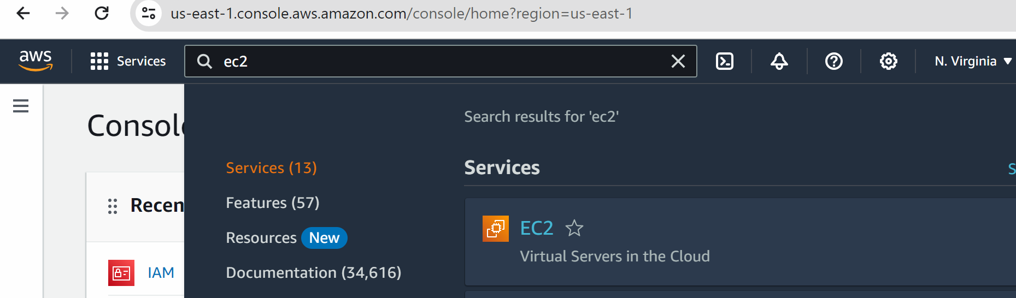

Click on instances -> launch instance

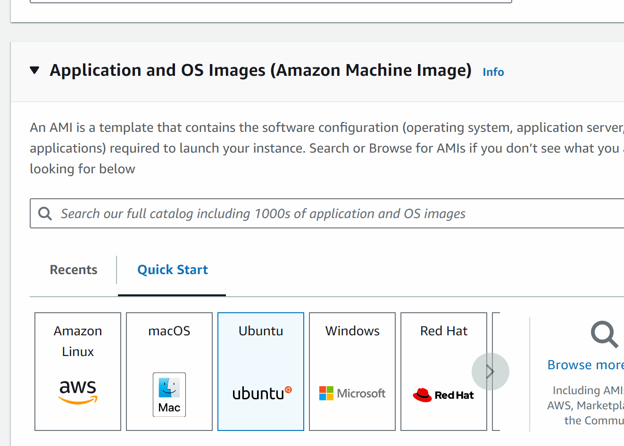

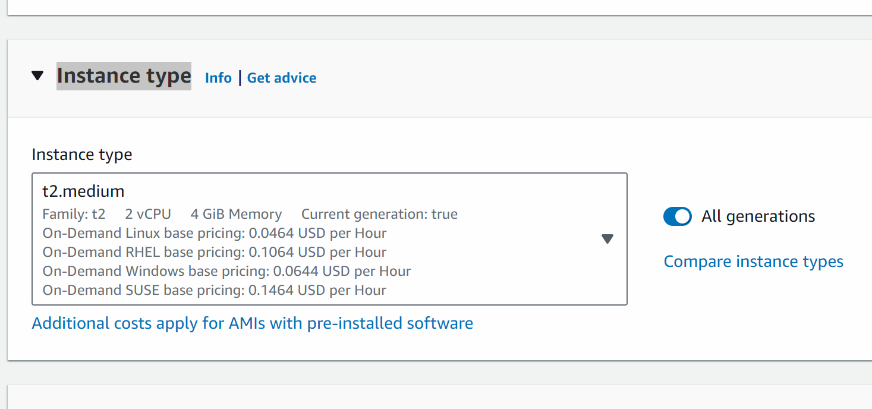

Create new keypair

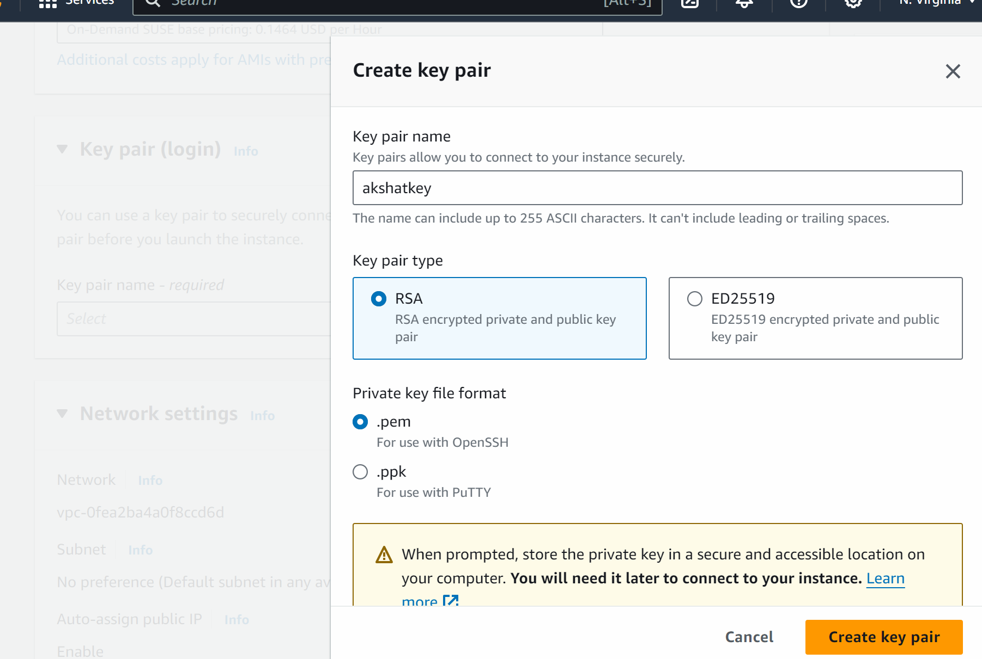

Givename and click on create keypair

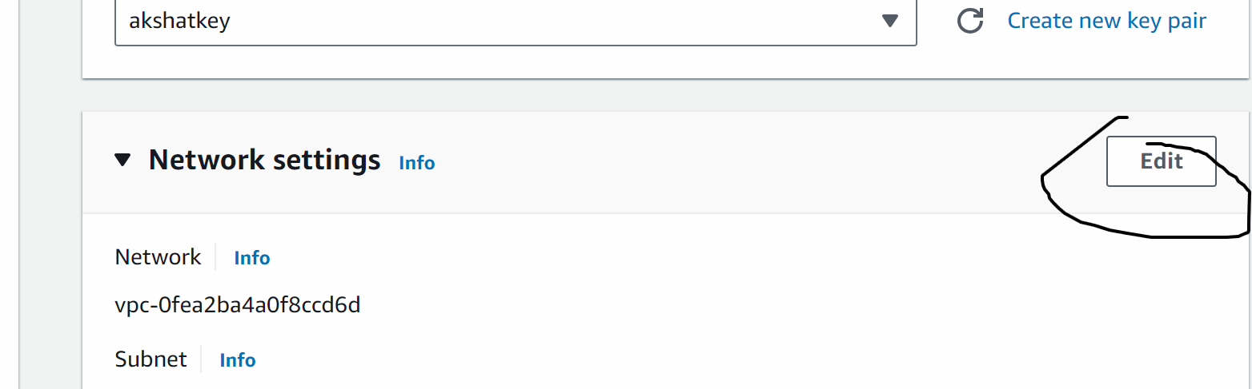

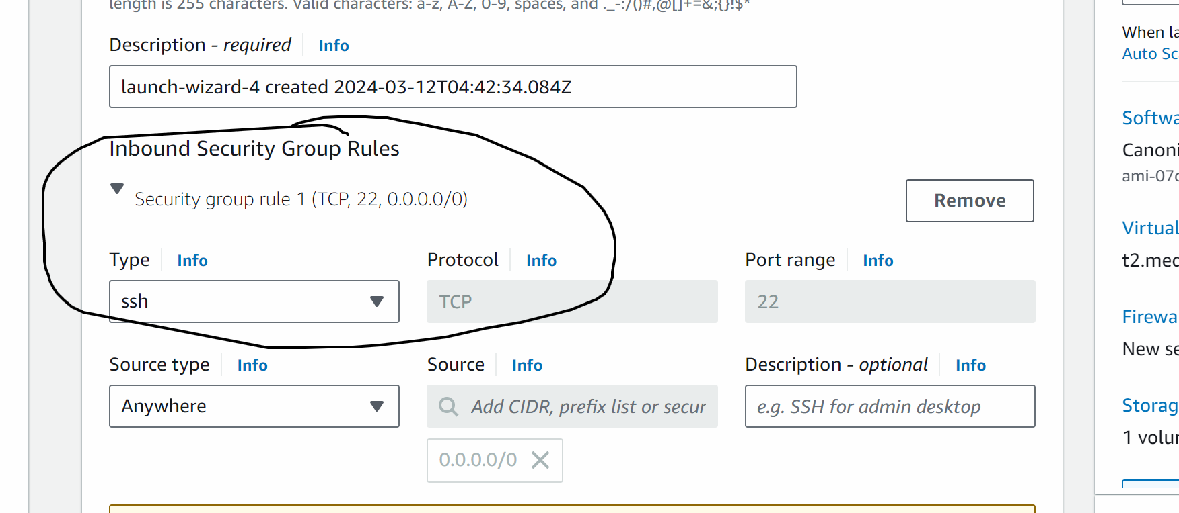

Change type ssh to anywhere

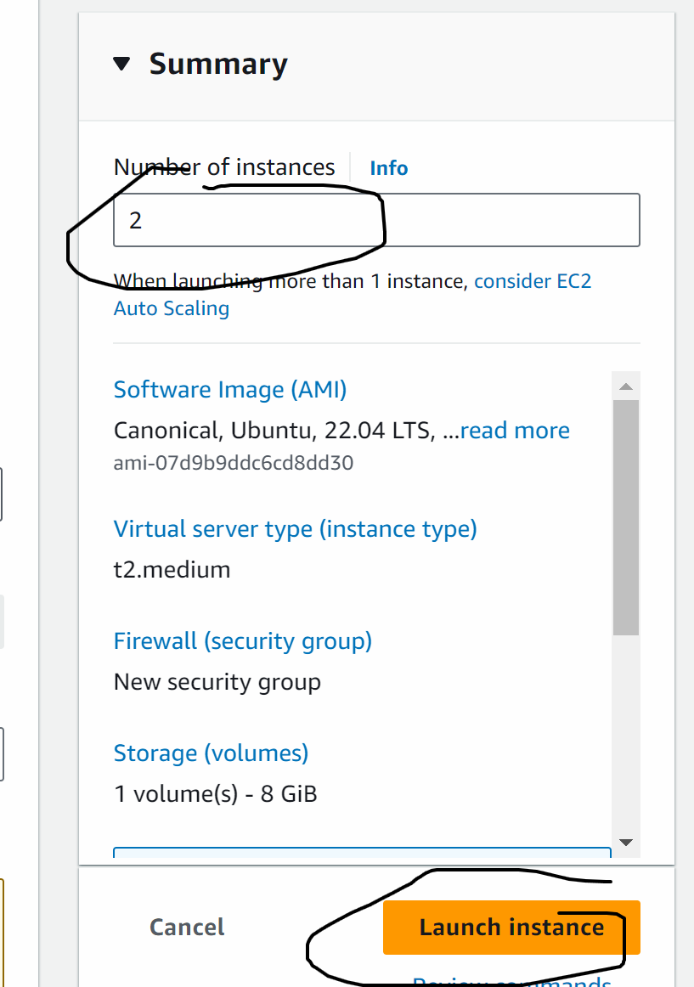

Now you can rename the machine as master-docker and node machine

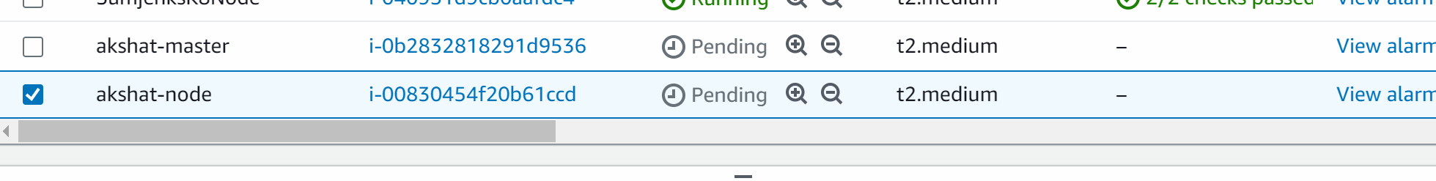

Select the node

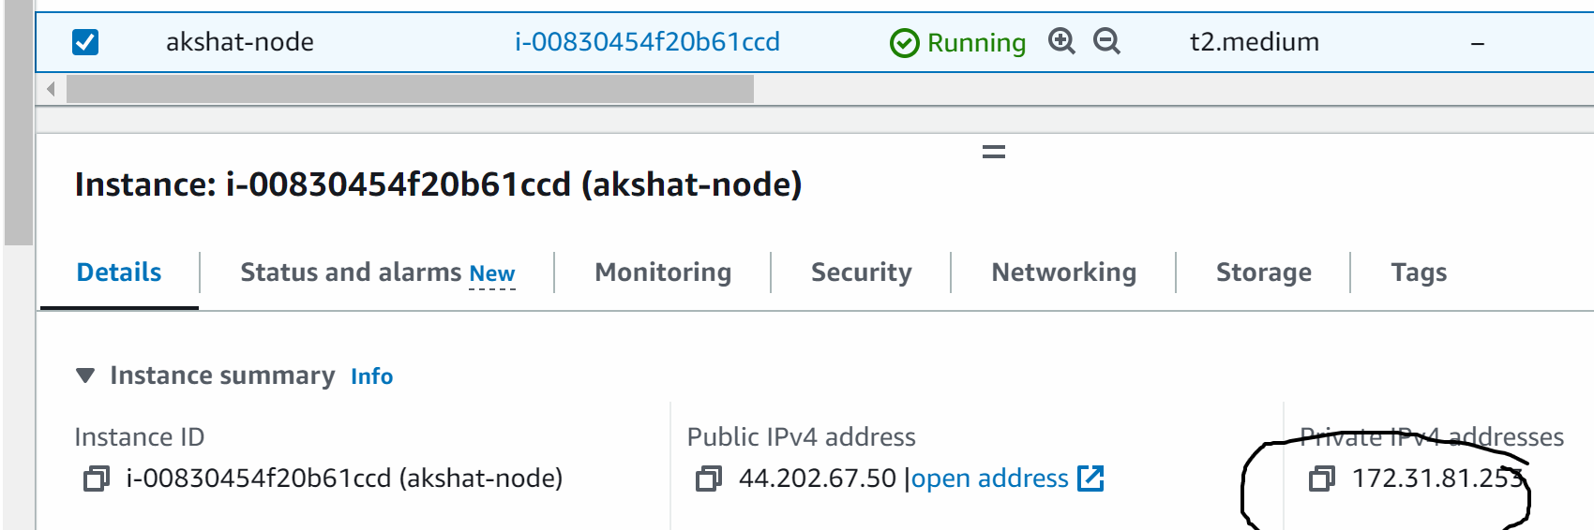

Copy the private ip

**Now go back to jenkinsfile in github**

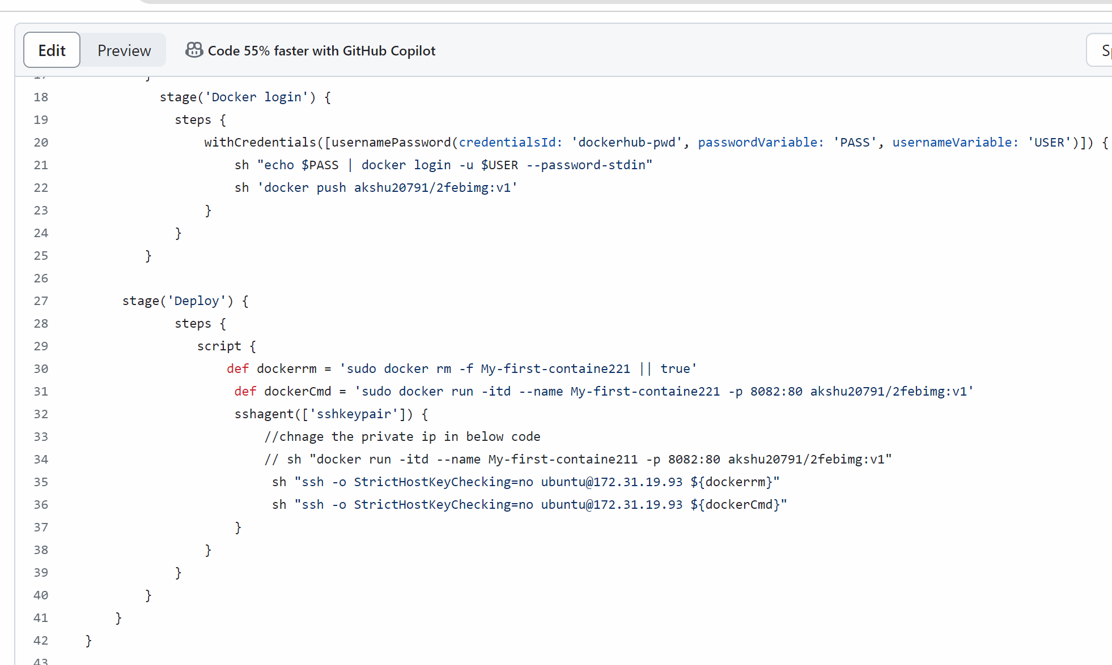

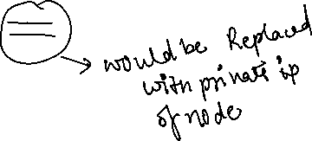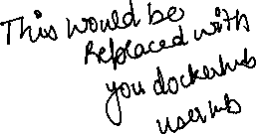

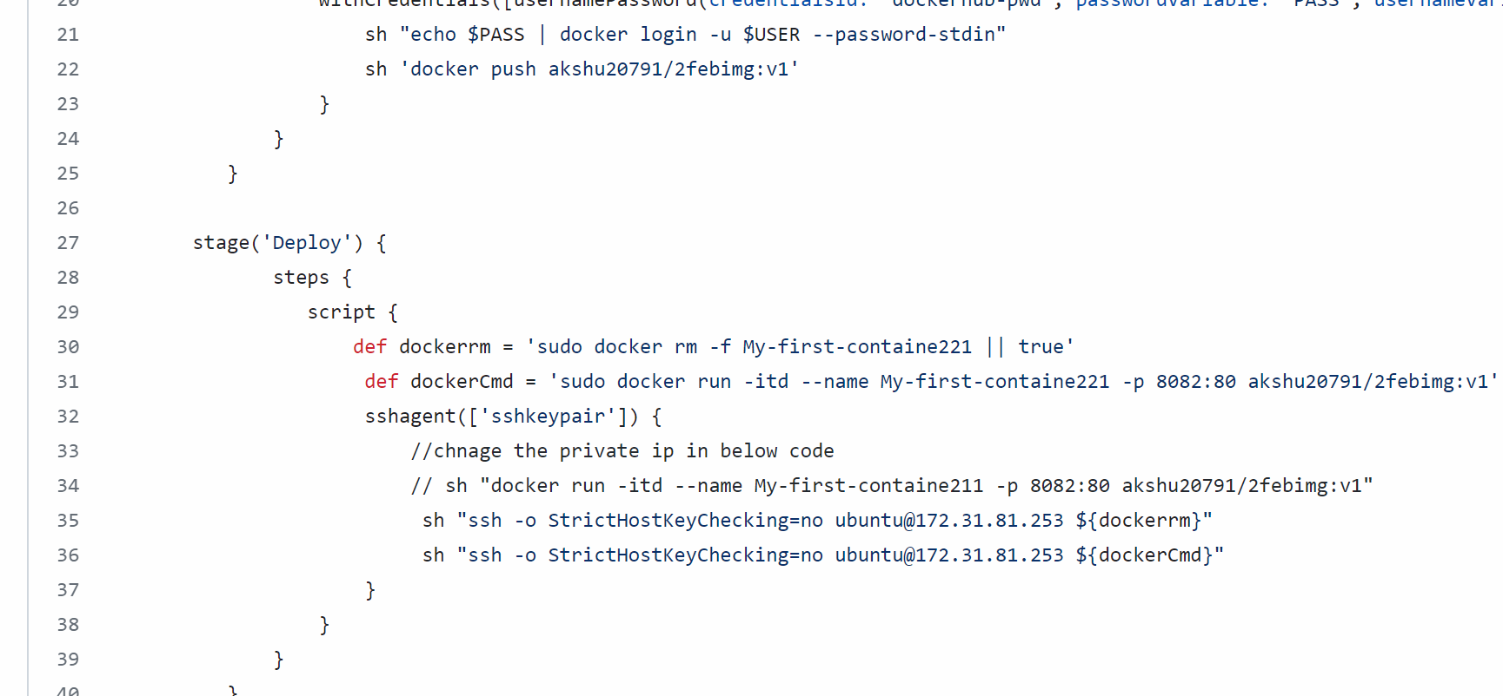

Click on commit to commit the changes you made in jenkinsfile



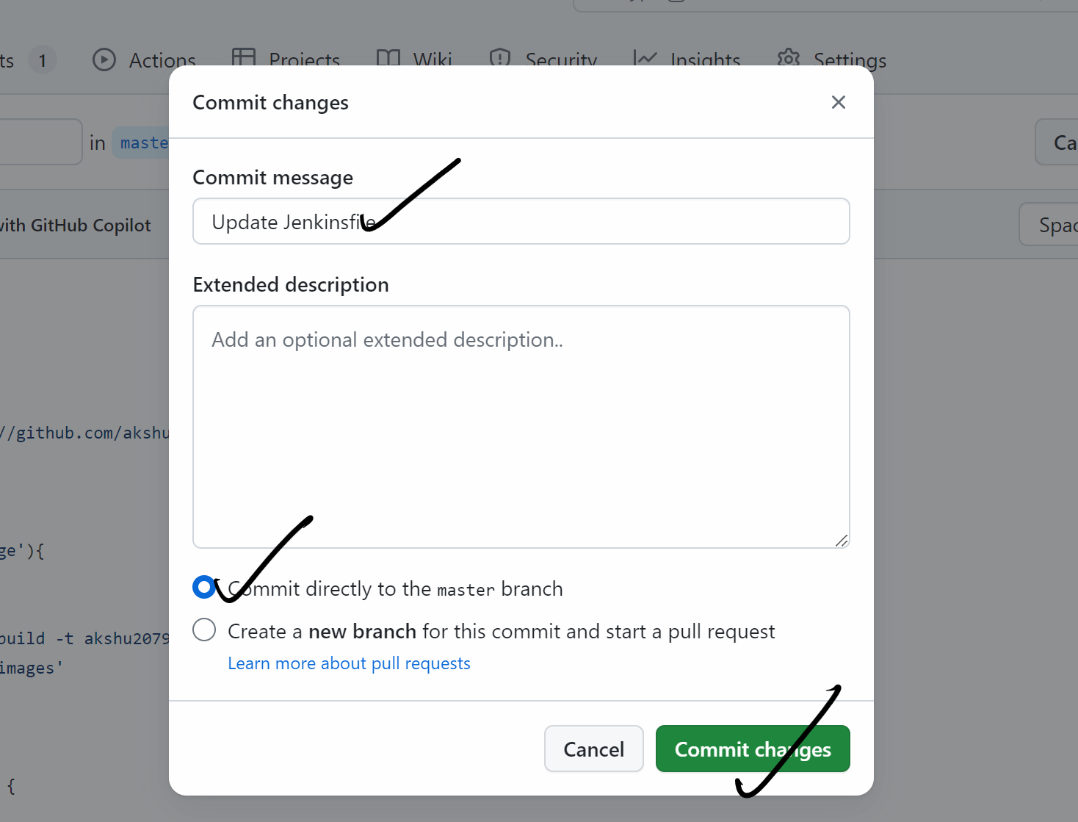

#########################

Go to the master machine and we will install Jenkins and docker in the master machine

Connecting the machine:

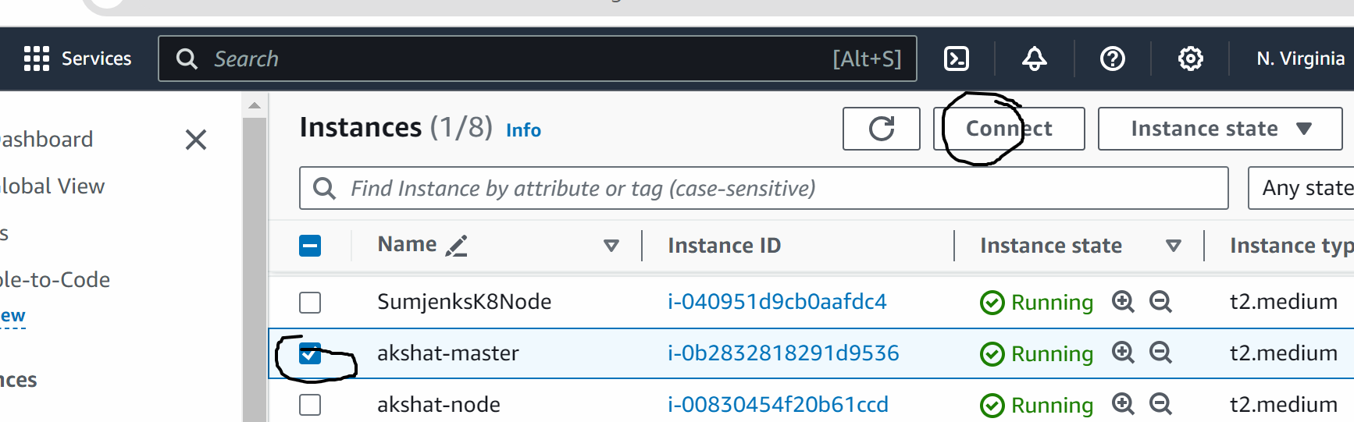

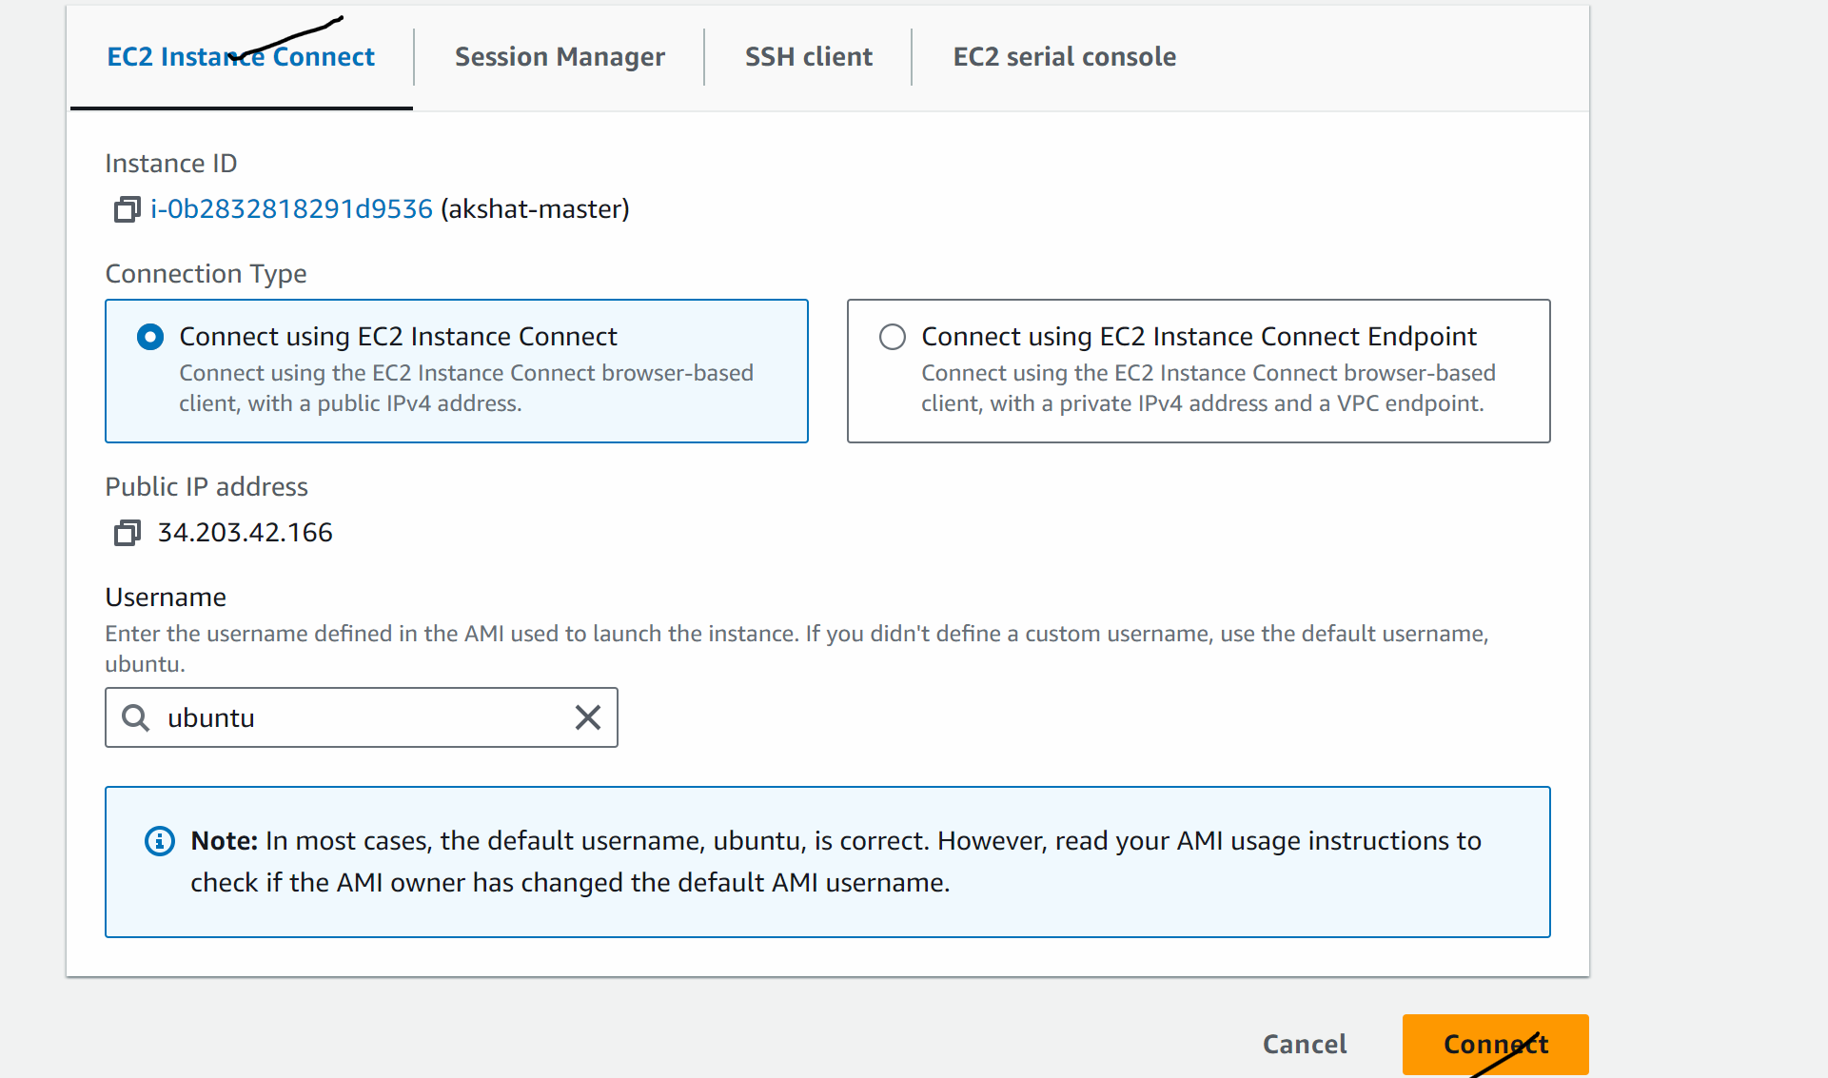

Lets now install Jenkins (follow the way I am doing no changes)

sudo su

wget <https://raw.githubusercontent.com/akshu20791/Deployment-script/main/jenkins.sh>

ls

chmod 700 jenkins.sh

./Jenkins.sh

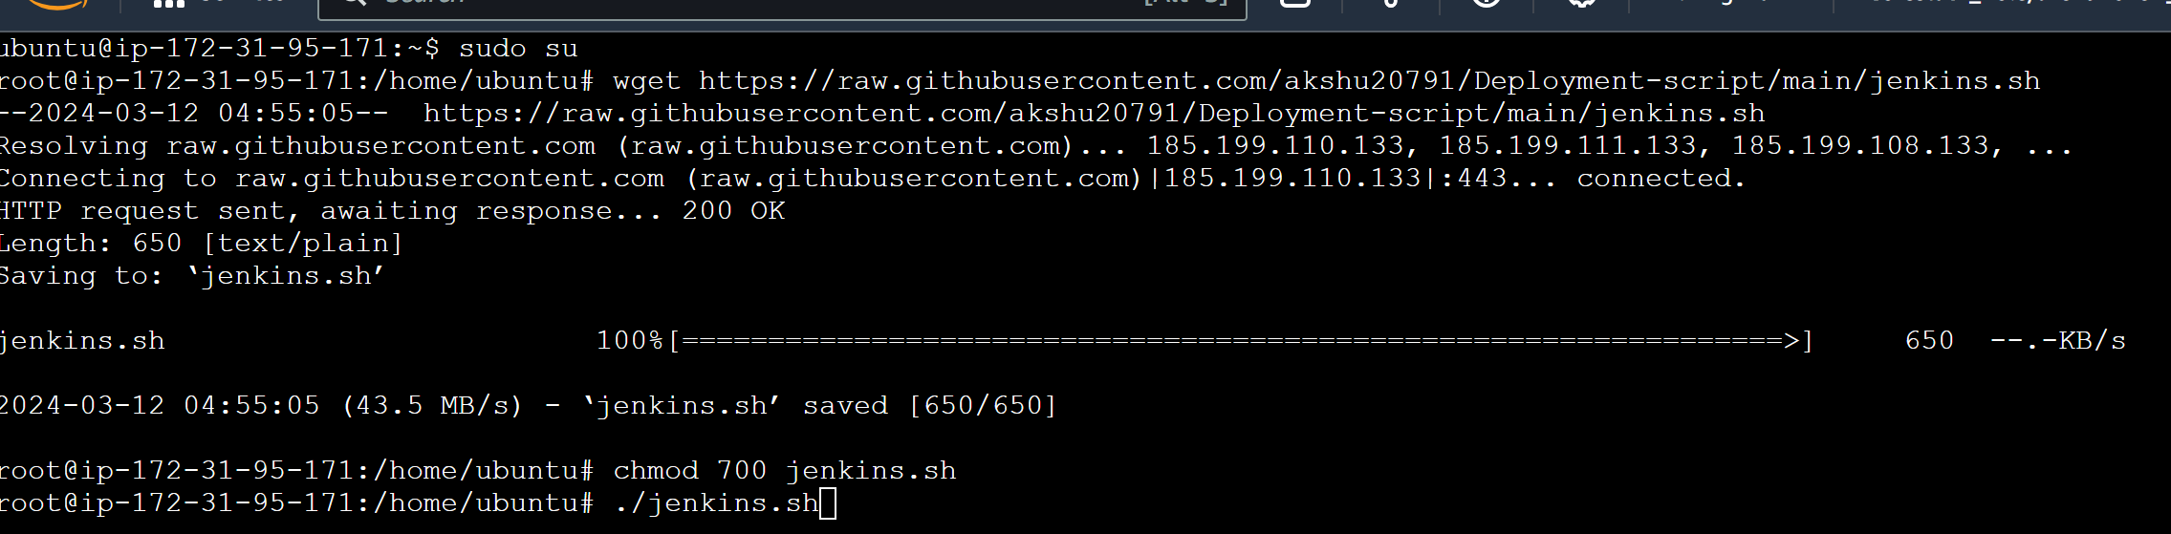

At the a pass will come

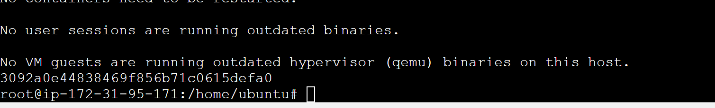

Now copy the public ip of the master machine and open it on port 8080

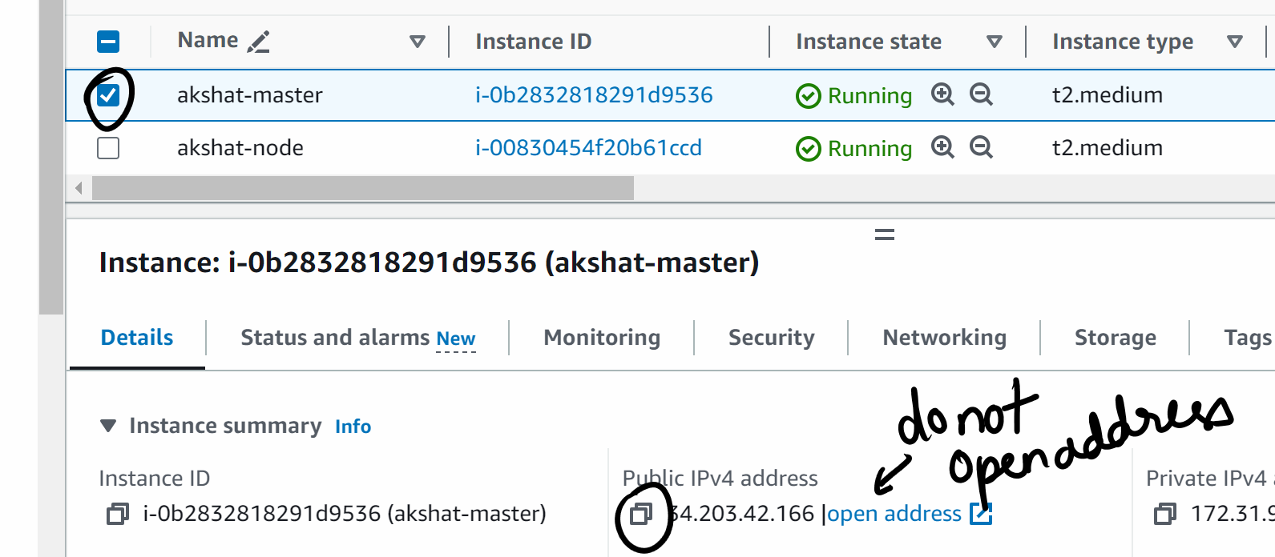

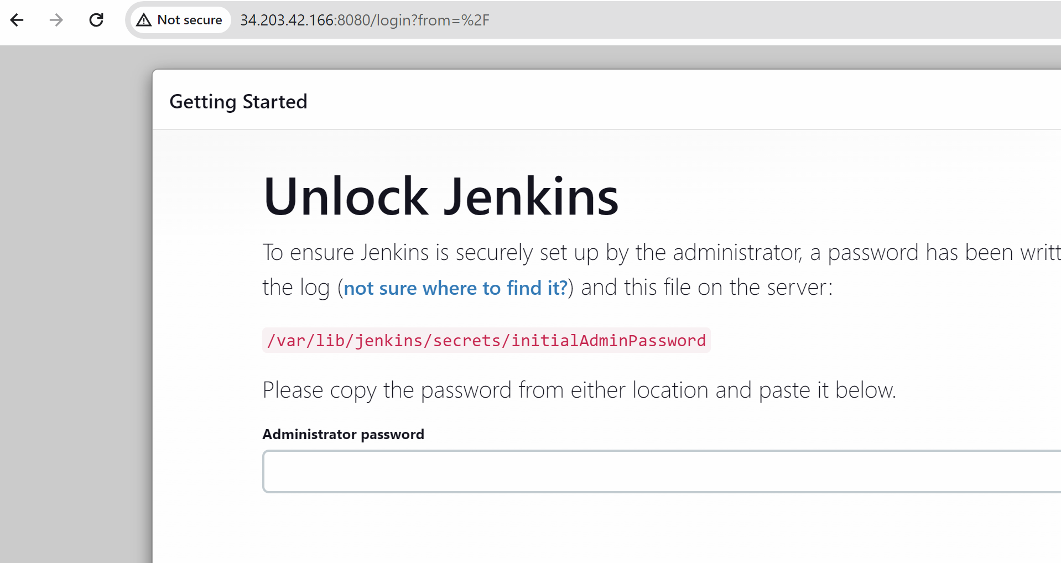

Copy paste the pass which u generated above in administrator pass

Click on continue after pasting the pass

Install suggested plugins

In username passs ….everywhere put admin …in mail put [admin@gmail.com](mailto:admin@gmail.com)

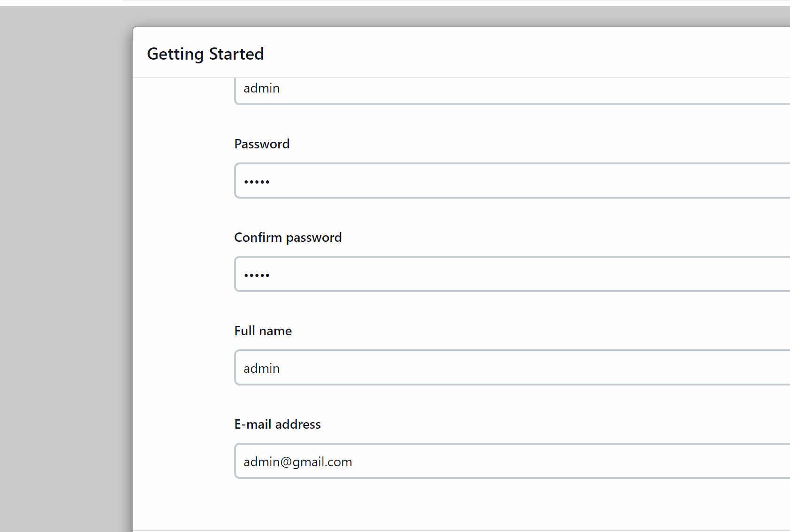

Save and continue

Save and finish

Start using Jenkins

Go to manage Jenkins -> credentials -> click on global

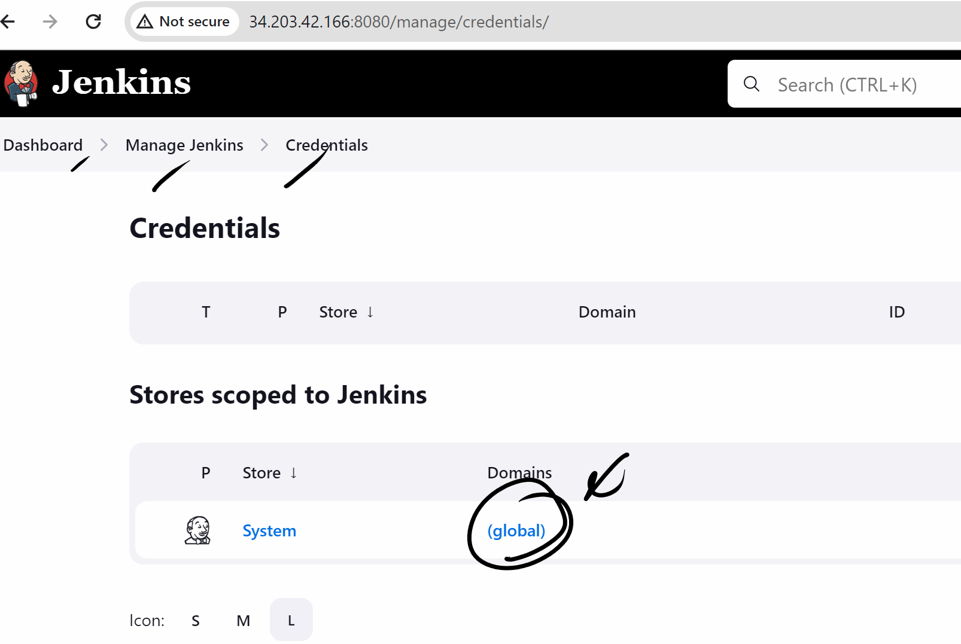

Add credentials button

First we will create dockerhub username and pass creds so that my Jenkins and login and push the image to dockerhub

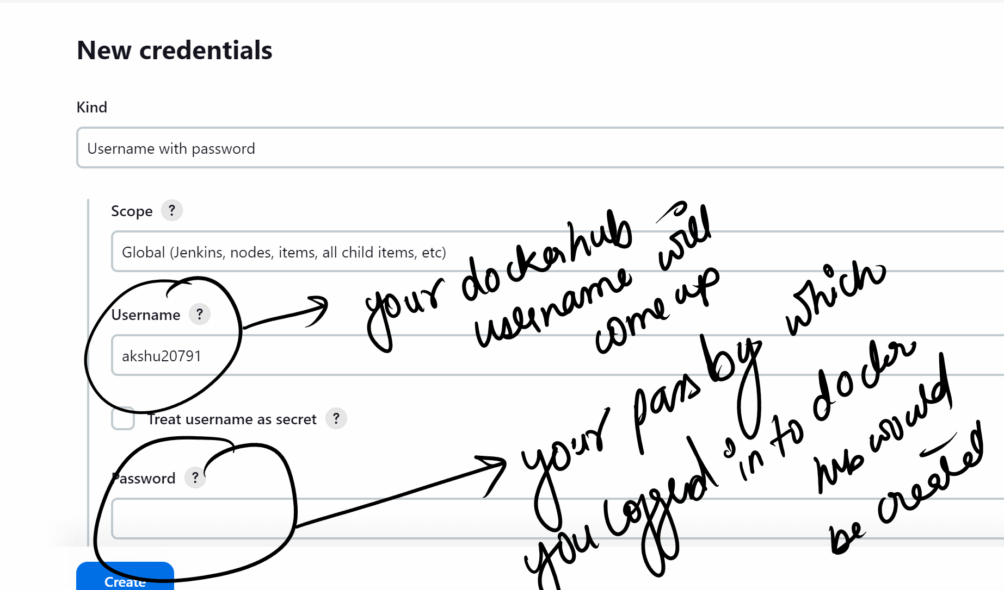

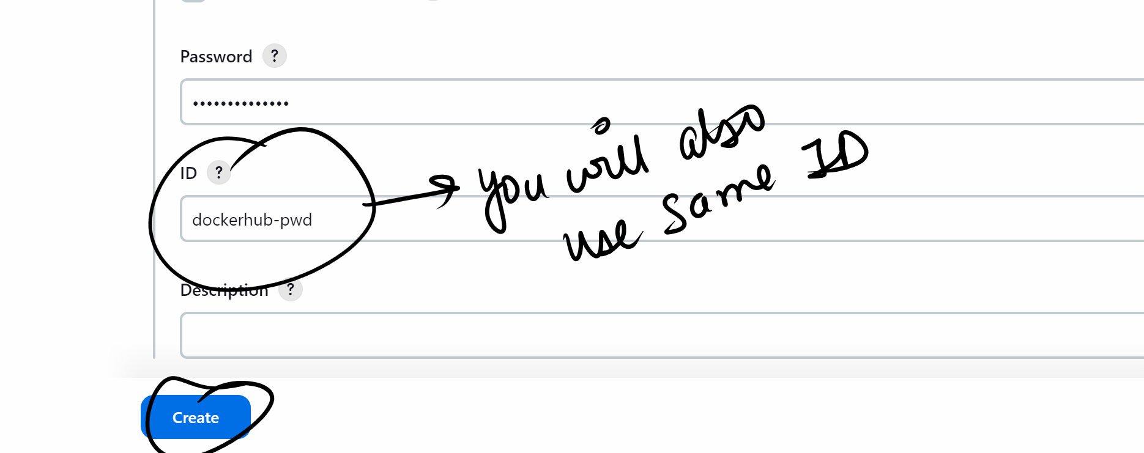

We will create credentials for ssh connection also

Add credemtials

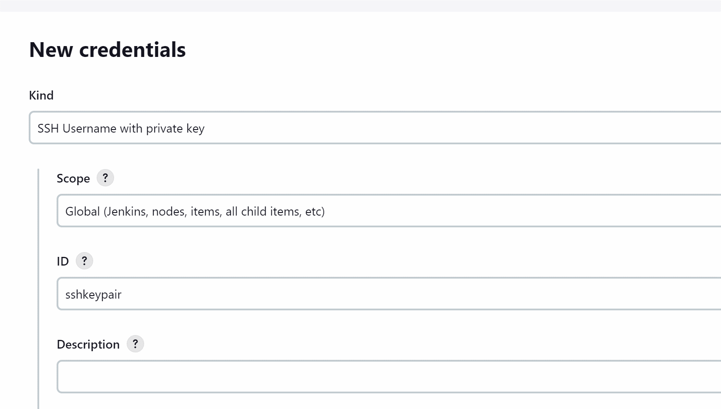

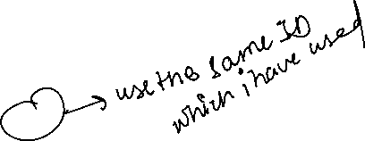

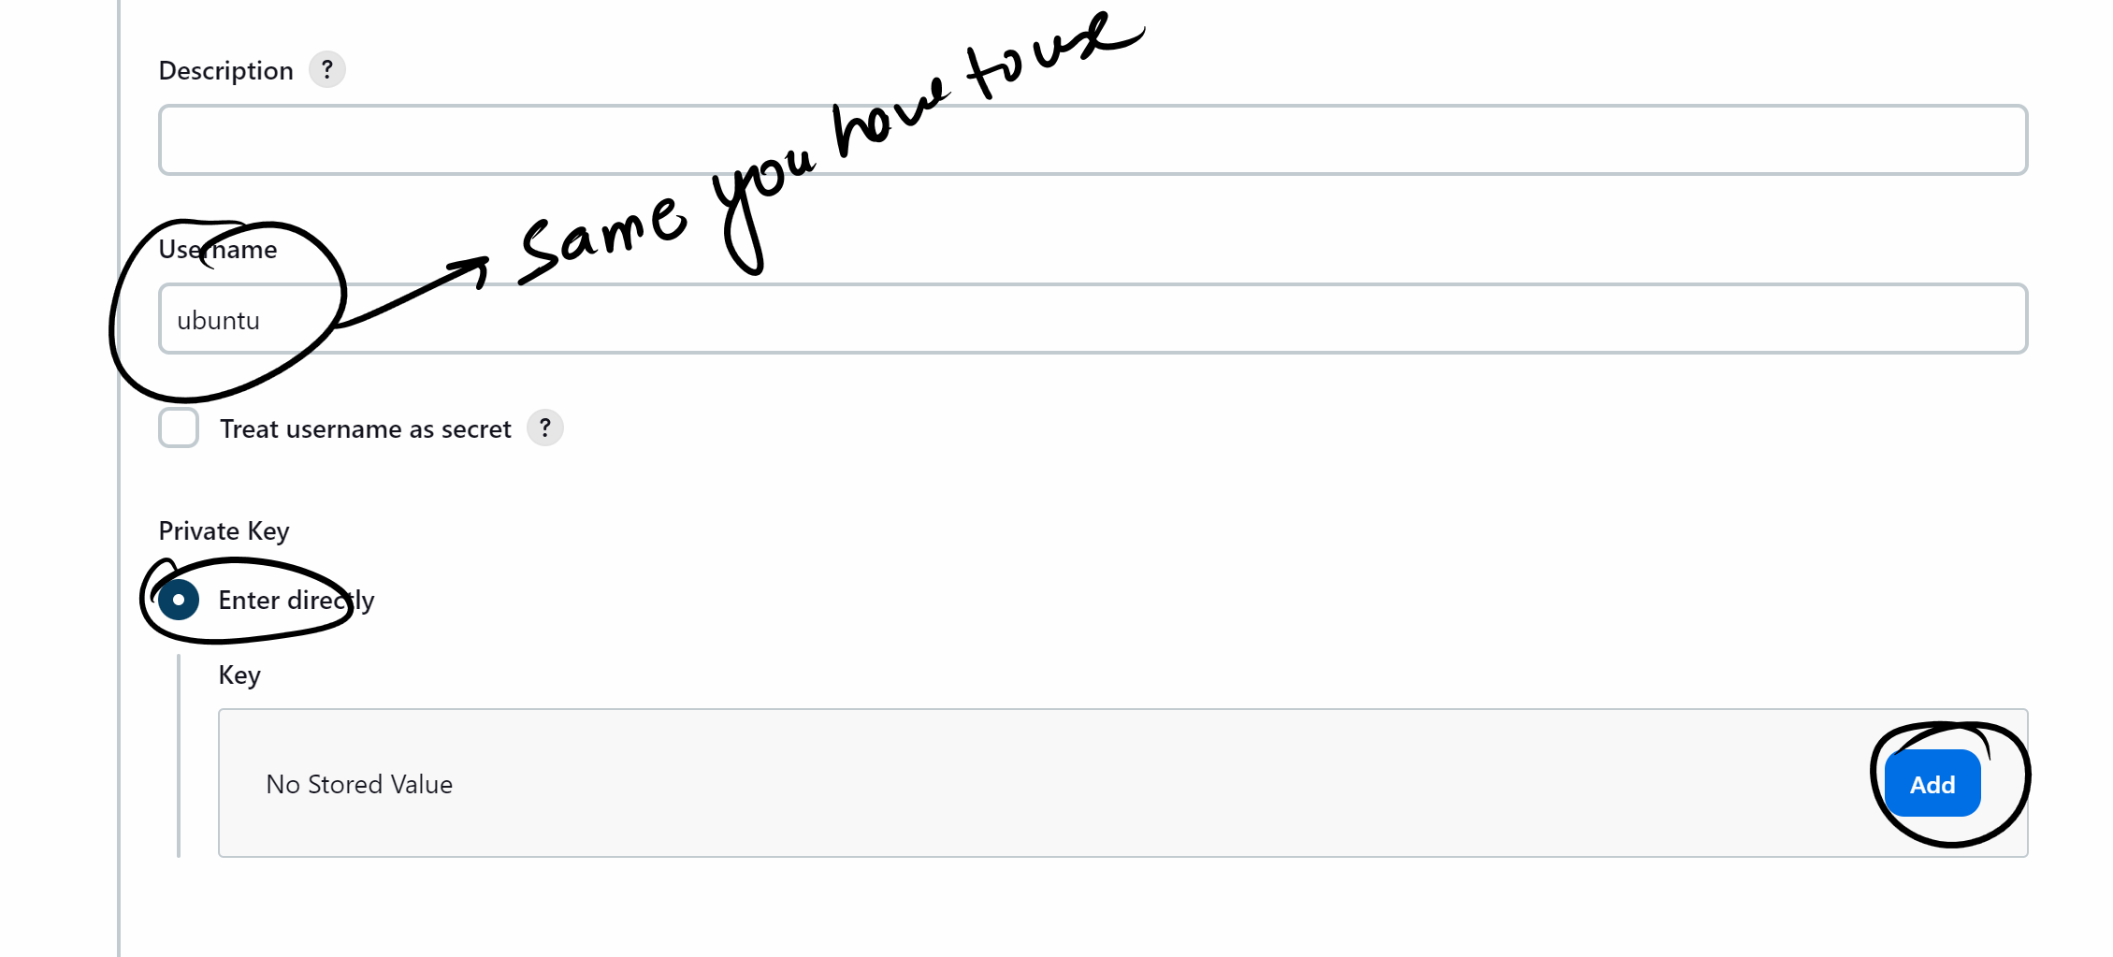

Now check downloads and open the keypair which u created while creating the node ec2 machine..in notepad and copy the whole key

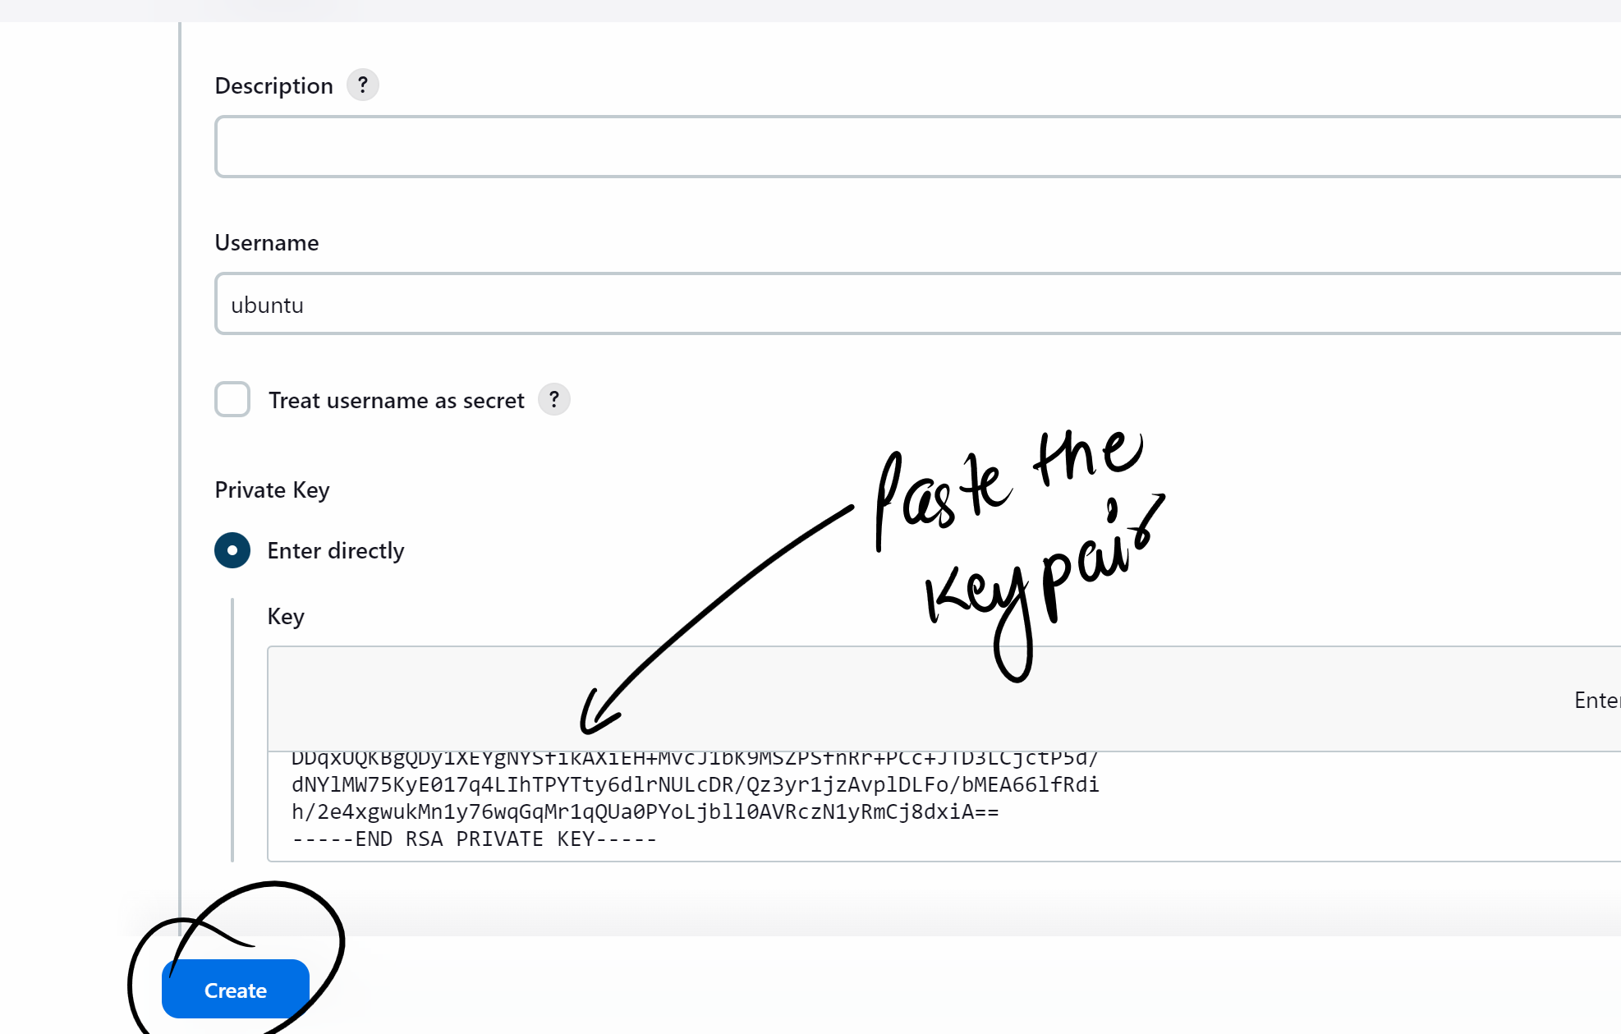

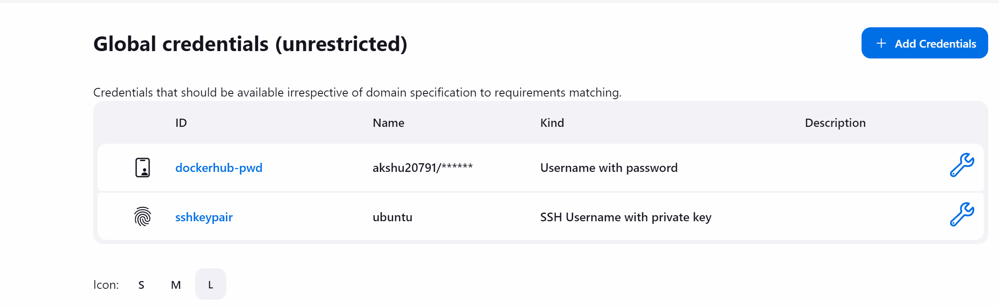

### now we will create pipeline

Go to Jenkins dashboard

+new item

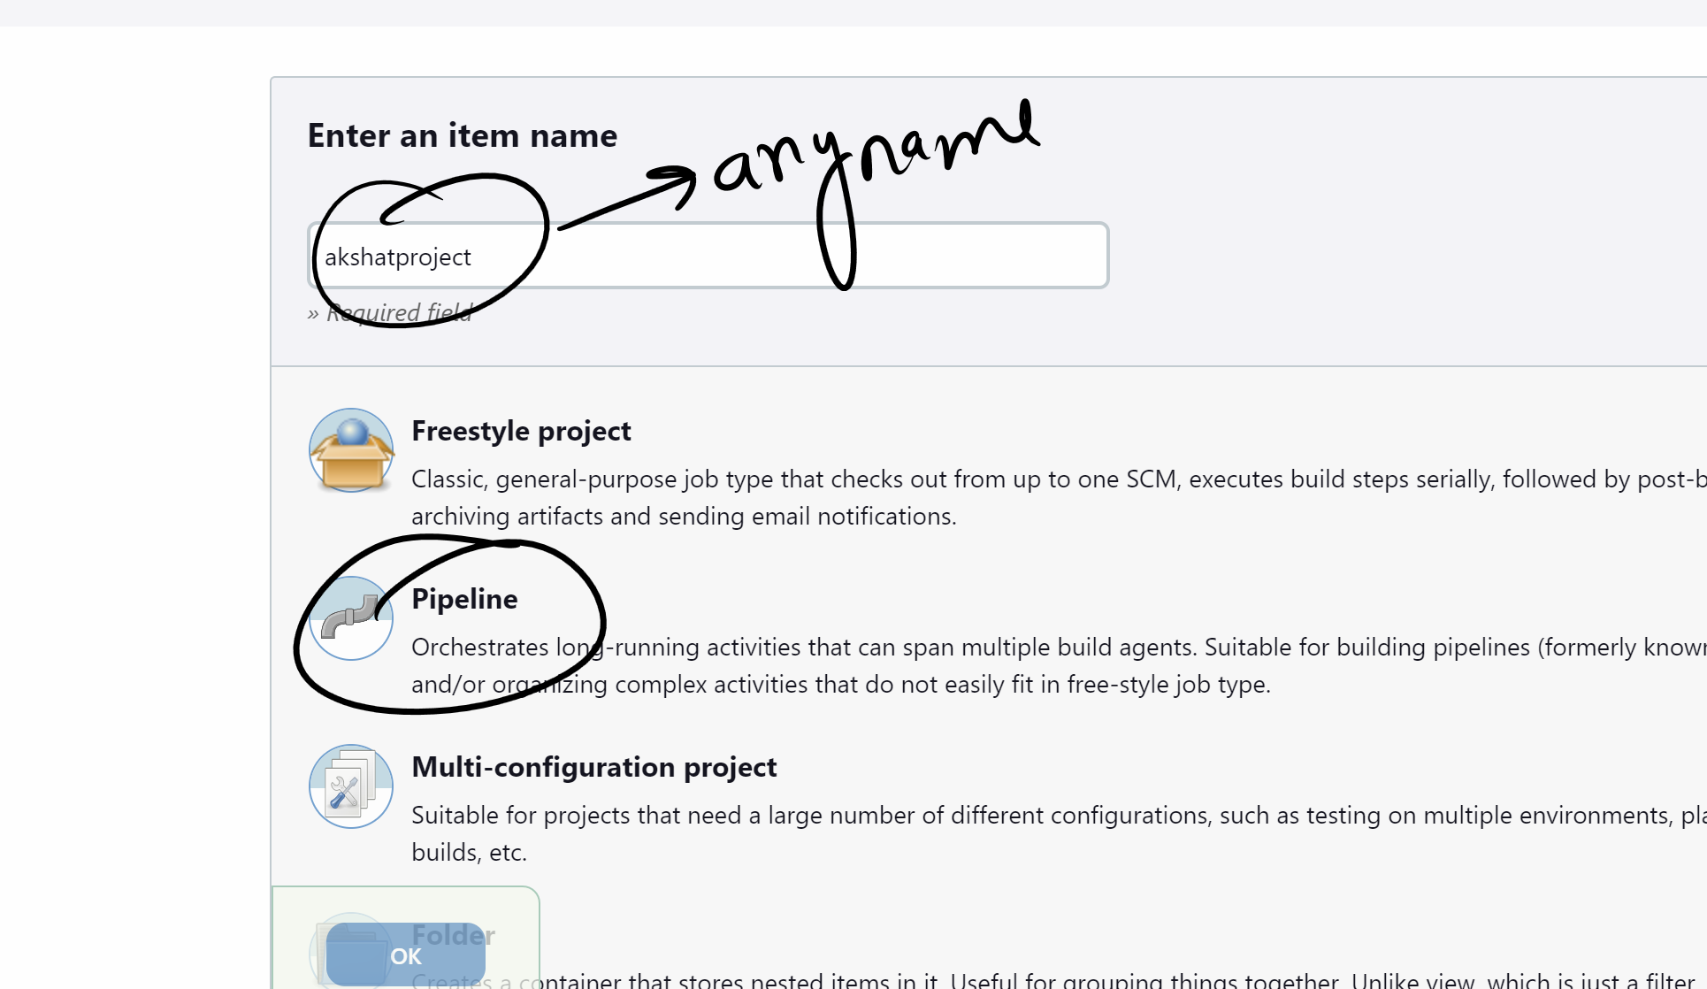

Ok

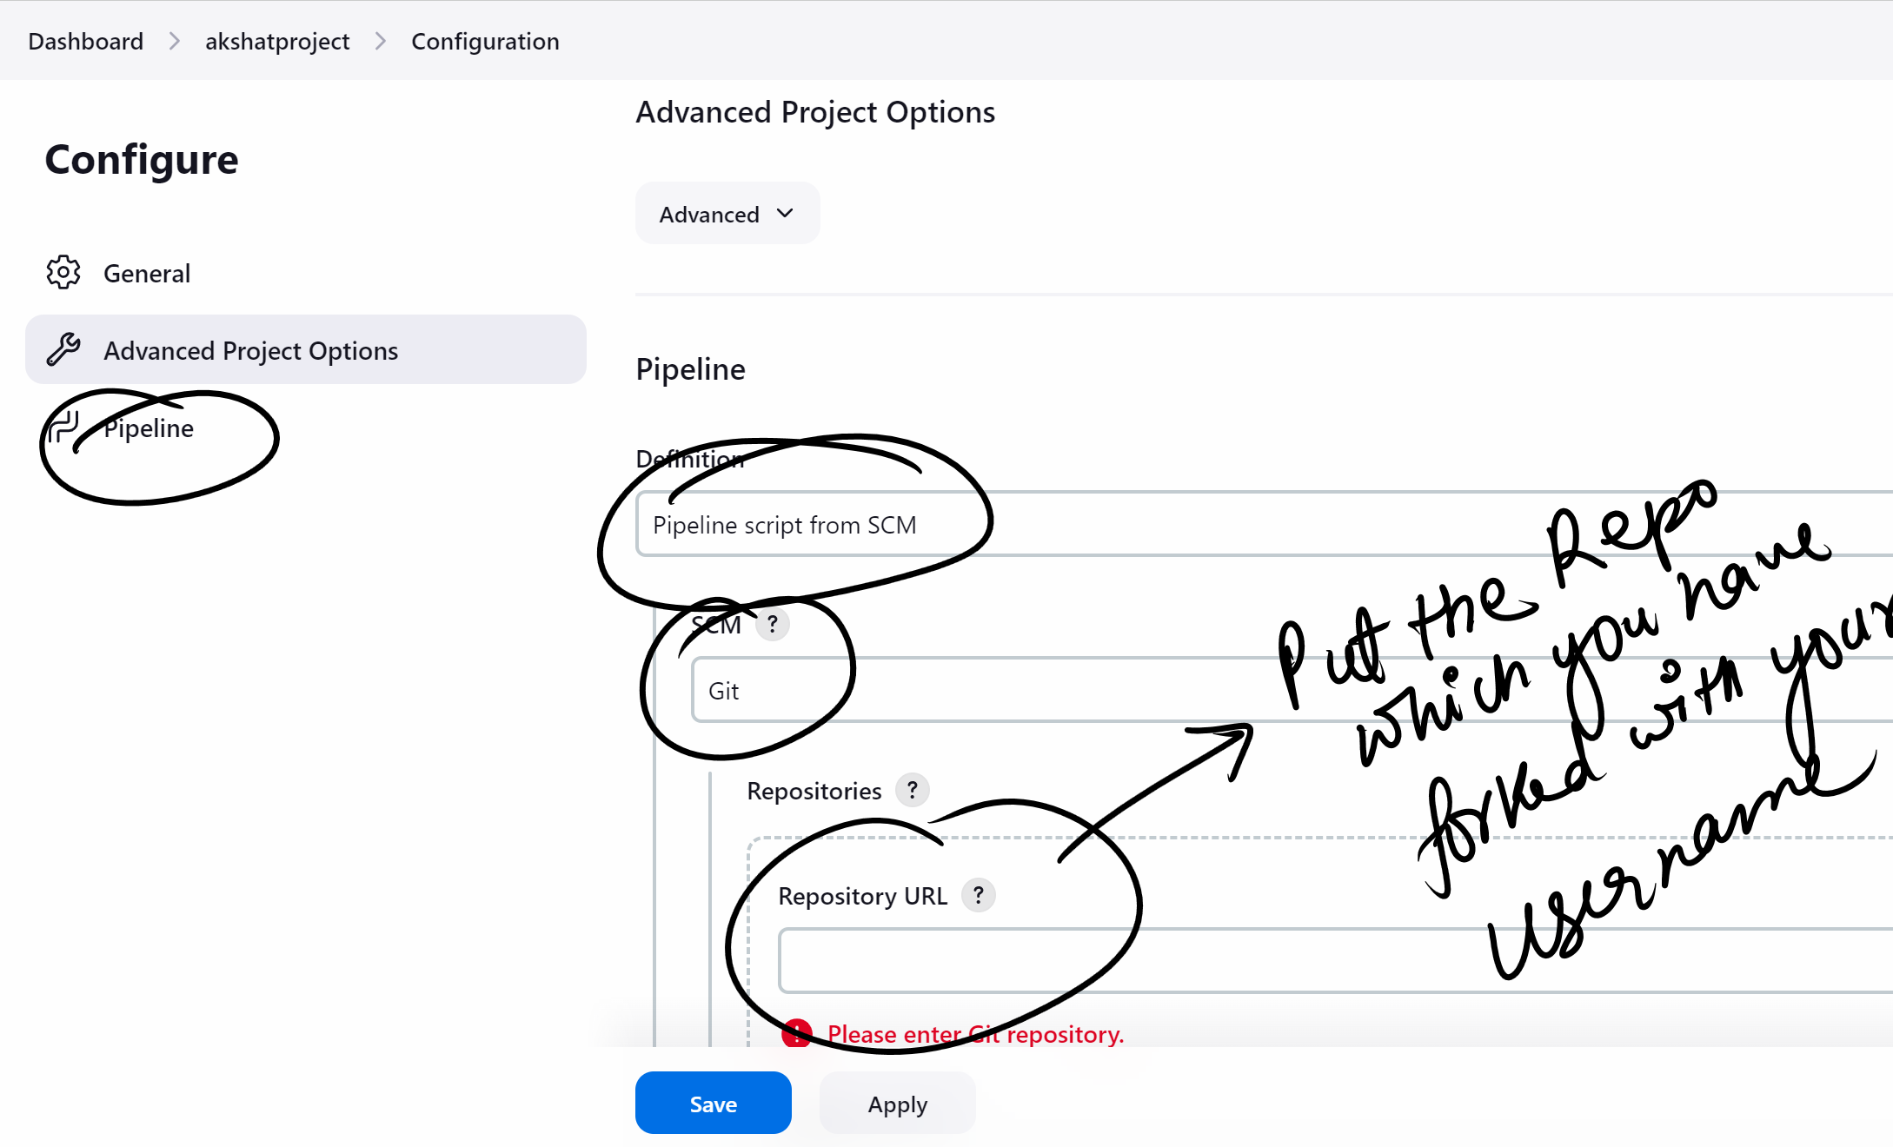

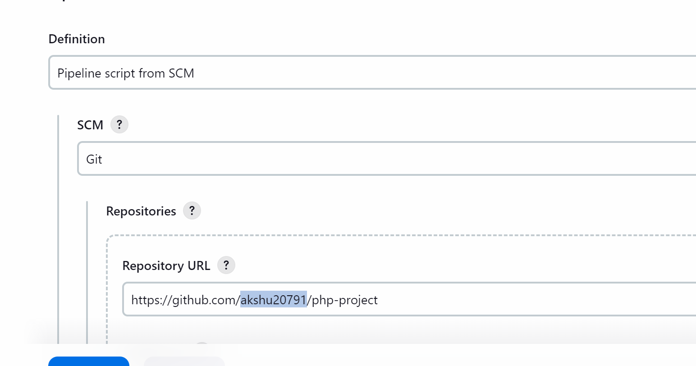Save

**########go back to your master machine #########**

apt install docker.io -y

service docker start



Now we will give the access to jenkisn user to access docker user

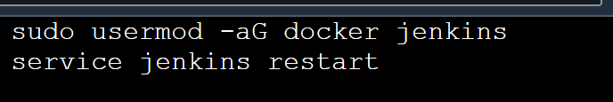

sudo usermod -aG docker Jenkins

service jenkins restart

################################################

Get into the node

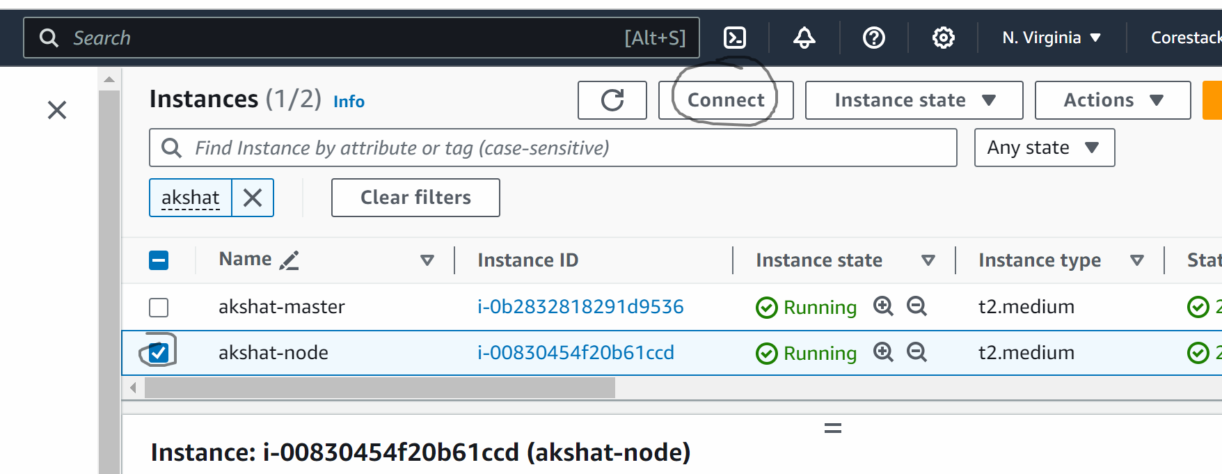

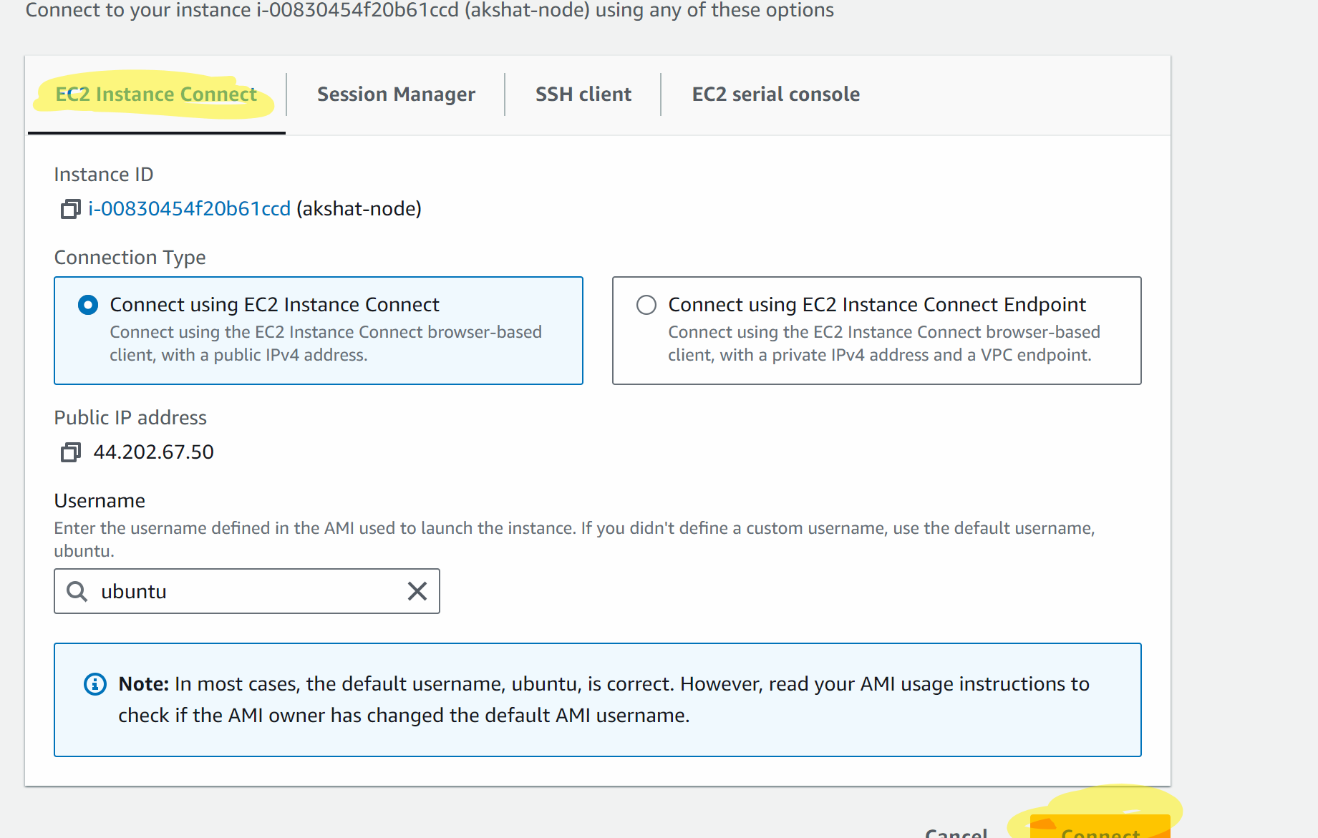

sudo su

apt update -y

apt install docker.io -y

service docker start

go to Jenkins and refresh the browser

Relogin

Go to Jenkins dashboard

Go to manage Jenkins -> plugins -> available plugins

Search for docker

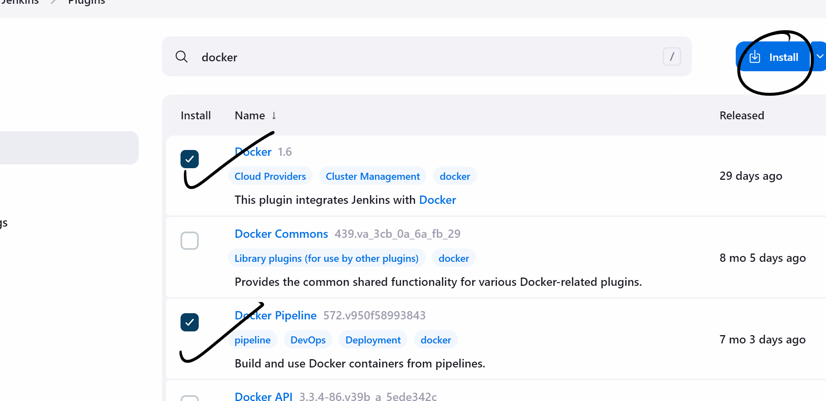

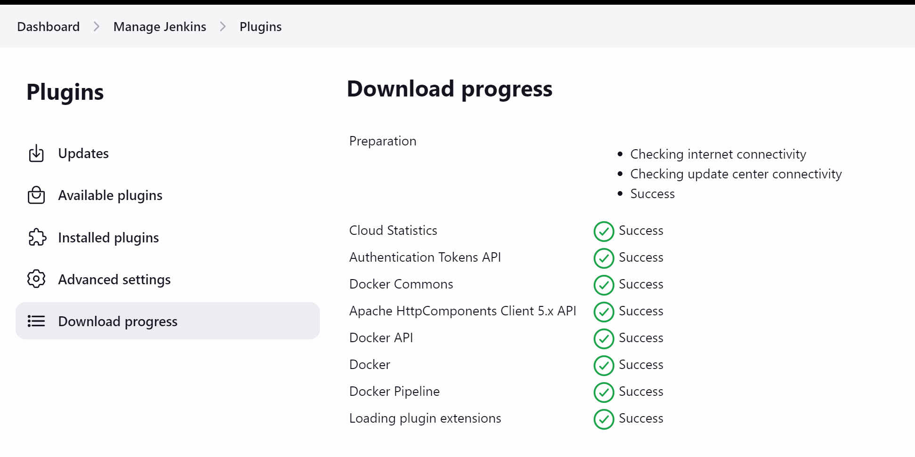

Now again click on available plugin

Search ssh

Install ssh agent plugin

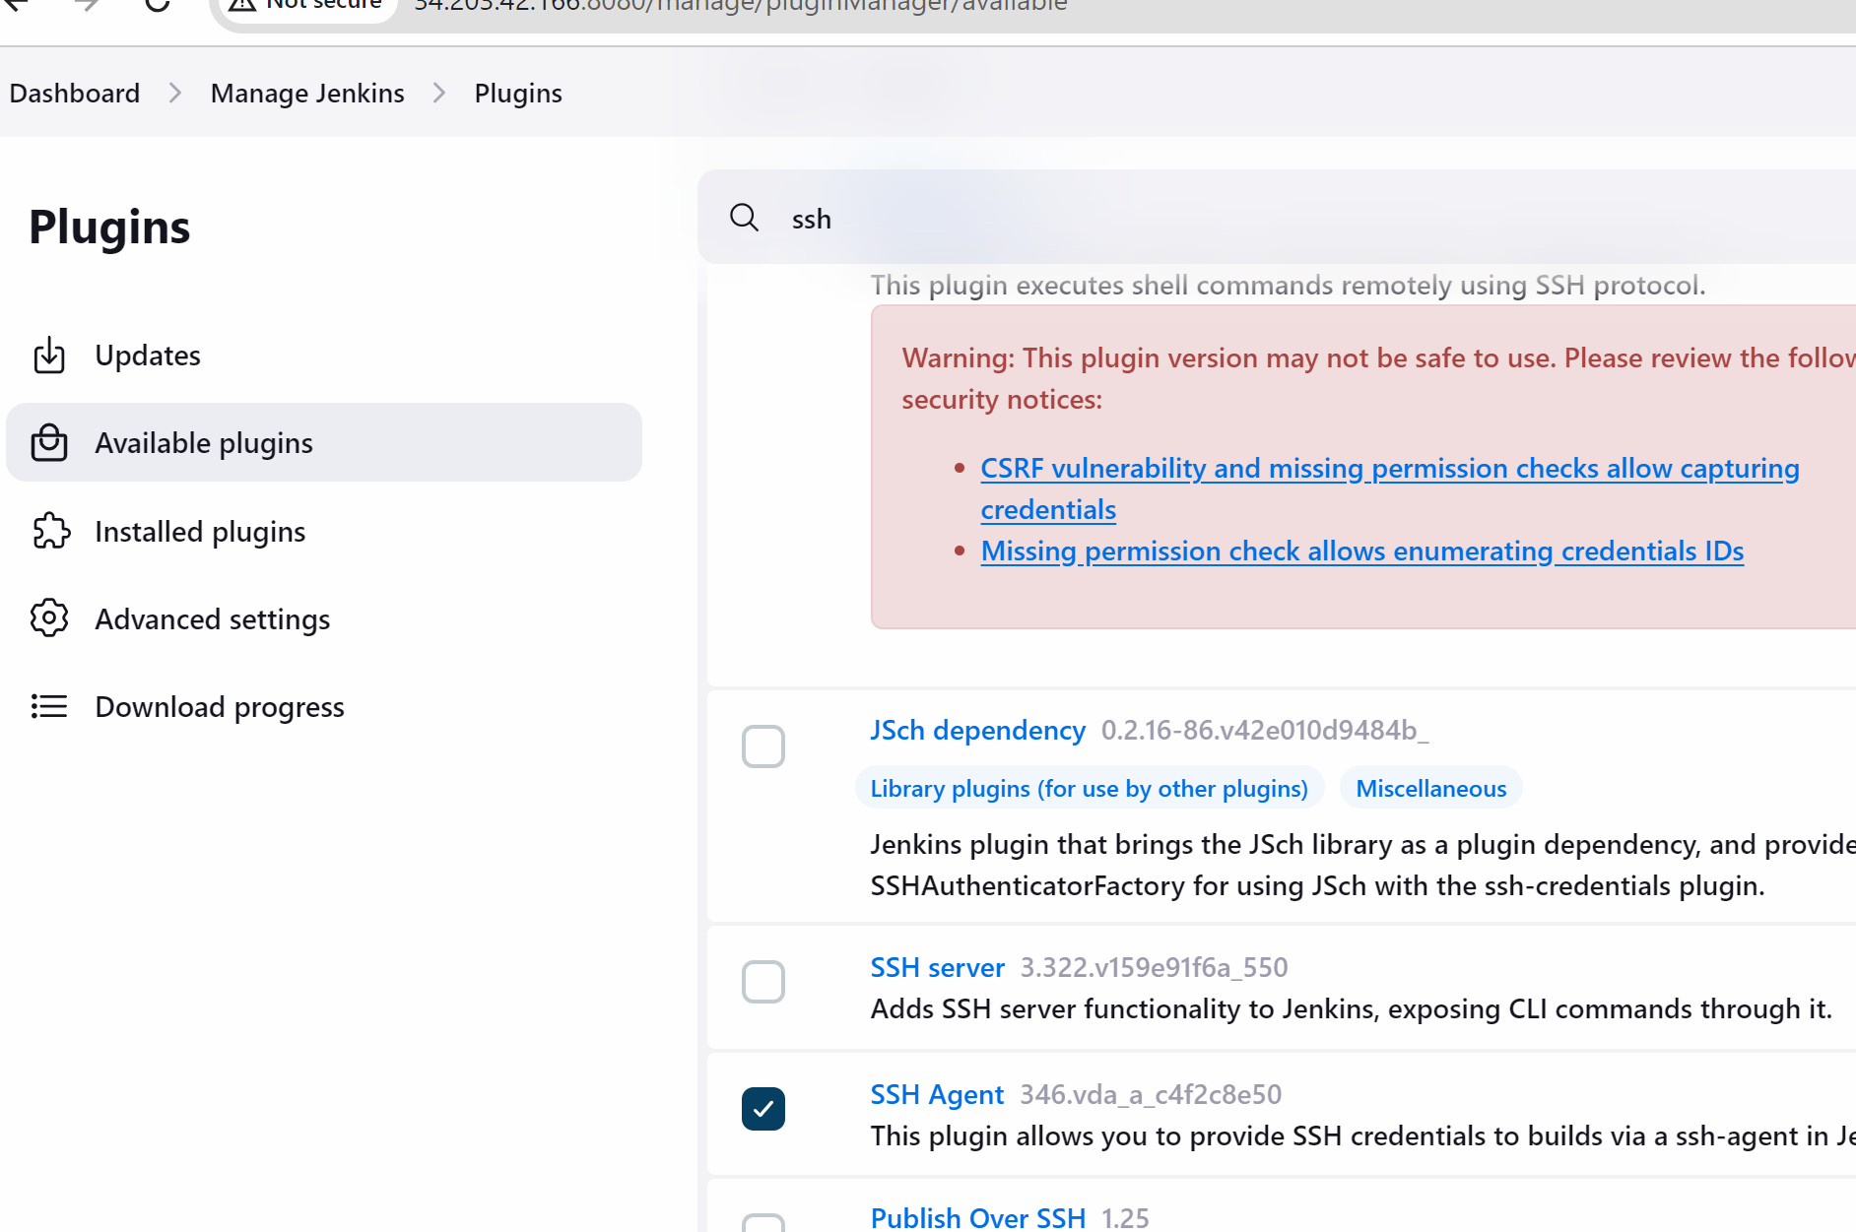

Click on install

Go back to dashboard

Click on project

And build the project

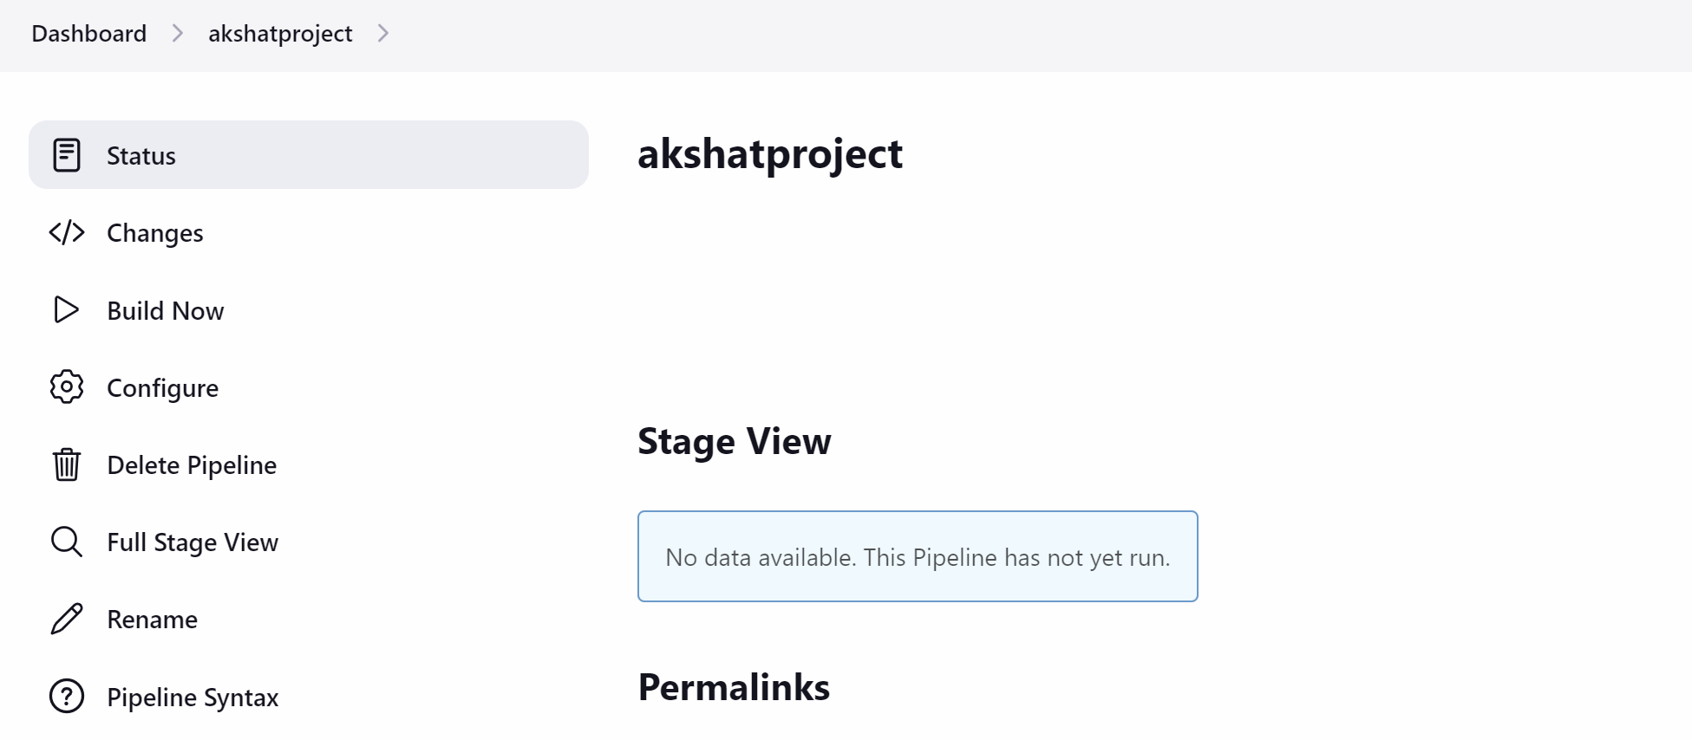



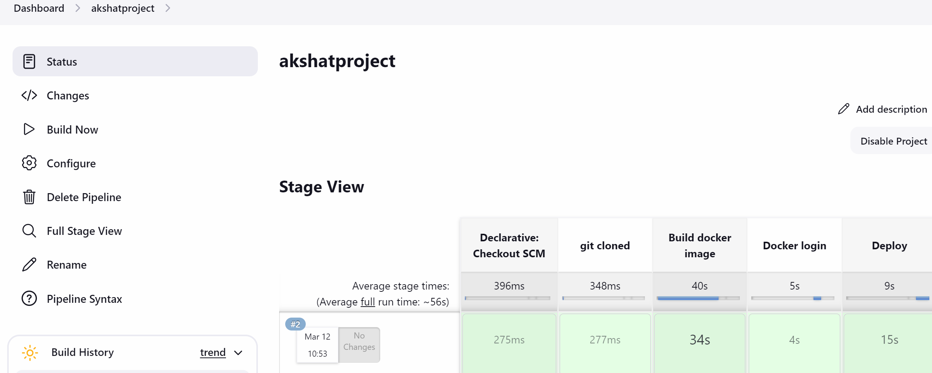

**Go to aws …copy the node public ip address ….**

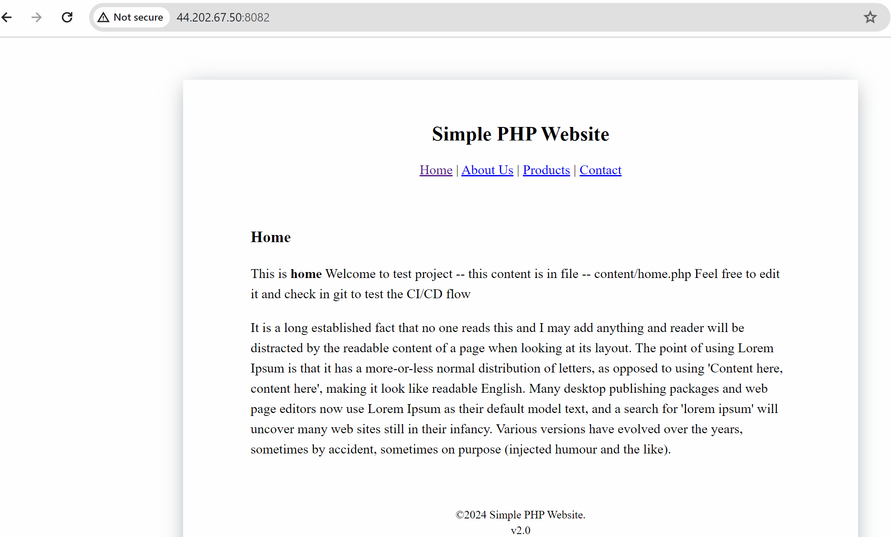

**App is running**